1.Describe doubly linked list with advantages and disadvantages. Write a C function to delete a node from a circular doubly linked list with header node**.**

2. Develop a C function to implement the following doubly linked list ,

1. insert a node at the front end.
2. delete a node at front end.
3. Search a node with a given key value

3.Defne tree. Explain any six terminologies.

4. Develop a C function to implement the following doubly linked list ,

1. insert a node at the rear end.
2. delete a node at rear end.

5. Define binary tree. Construct a binary tree from the Post-order and In-order sequence given below In-order: GDHBAEICF Post-order: GHDBIEFCA

6. Draw a binary tree for following expression (6+(3-2)*5)^2+3. Traverse the above generated tree using preorder, postorder and also write their respective C function

7. Represent the below given tree using

1. Linked representation
2. Left child right sibling representation.

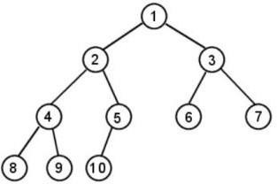

8. Define Forest. Transform the given forest into a Binary tree and traverse using inorder, preorder and postorder traversal

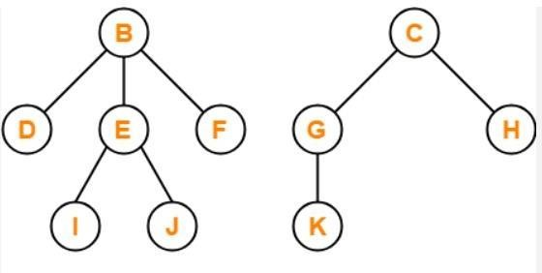

9. Explain collision. Resolve the collision using linear probing, insert the keys 63, 81,14,55, 92 ,34,60 and 101 into the table. Consider a hash table of size 10.

10. Define hashing. Explain the hash functions with suitable example.

11.Difference between static and dynamic hashing.